|  |
| --- |
| densys3D_Logo |
| **Mia3d**  **Intra-oral 3D Imaging System** |
| Operator’s Manual |

|  |
| --- |
| The densys3D system comprises an intra-oral scanner and a third party CAD/CAM workstation at the dental lab or central production. The scanning process is straightforward and simple, guided by visual and audible prompts. A complete scan takes just a few minutes, after which a digital file is transferred to a dental lab for completion of the restoration. |



**Copyright © 2012 densys3D Ltd. All rights reserved.**

Manual Document No.: LBL-01-01

Manual Revision Level: 19

Manual Revision Date: June 2018

**Authorized Representative in the European Union:**

Advena Limited  
Pure Offices, Plato Close, Tachbrook Park

Warwick. CV34 6WE. United Kingdom

Registered in England & Wales No. 3517275   
Tel: +44 1926 800153  
Email: info@advenamedical.com



This device complies with applicable requirements of the Council Directive93/42/EEC

**This product is covered by one or more of the following patents as well as a number of pending patents:**

**US8,665,257, US6,402,707, US7,724,932, US7,330,577, JAP 5106418.**

**EP 1296592, EP 1997046**

TABLE OF CONTENTS

[Introduction 4](#_Toc523211577)

[Preface 4](#_Toc523211578)

[Conventions 4](#_Toc523211579)

[User License Agreement 5](#_Toc523211580)

[Indications for use 5](#_Toc523211581)

[Densys3D Hardware 6](#_Toc523211582)

[Wand Hardware Description 7](#_Toc523211583)

[Wand Physical Description 7](#_Toc523211584)

[Work Station Description 7](#_Toc523211585)

[Safety Standards 8](#_Toc523211586)

[Electrical Hazards 8](#_Toc523211587)

[Operational Environment 10](#_Toc523211588)

[Non-operational Environment 10](#_Toc523211589)

[Disinfection and Cleaning 11](#_Toc523211590)

[Biocompatibility 12](#_Toc523211591)

[CAUTION 12](#_Toc523211592)

[Installation 13](#_Toc523211593)

[Unpacking and Inspection 13](#_Toc523211594)

[Mia3D Operating Instructions 14](#_Toc523211595)

[Principal Navigation Aids 14](#_Toc523211596)

[Wizard Page Tabs 14](#_Toc523211597)

[Pre-Scan setup 15](#_Toc523211598)

[Activating the Application 15](#_Toc523211599)

[Patient Selection 16](#_Toc523211600)

[Restoration 18](#_Toc523211601)

[Pre-Scan Setup 19](#_Toc523211602)

[Scan Screen 20](#_Toc523211603)

[Help Tag 21](#_Toc523211604)

[Preview 21](#_Toc523211605)

[Scanning 22](#_Toc523211606)

[Audio 25](#_Toc523211607)

[Implants – Scan Bodies 25](#_Toc523211608)

[Scan Dialog Screen 26](#_Toc523211609)

[Finalize Last Scan 28](#_Toc523211610)

[Edge Marking 29](#_Toc523211611)

[Defining the Edge 30](#_Toc523211612)

[Scan History 33](#_Toc523211613)

[View 35](#_Toc523211614)

[Bite 36](#_Toc523211615)

[Scan Completion / Inserting Missing Areas 39](#_Toc523211616)

[Exporting Scans 40](#_Toc523211617)

[Exit Screen 43](#_Toc523211618)

[Contact Information 45](#_Toc523211619)

## Introduction

This document describes how to operate the densys3D Mia3d Intra Oral 3D Imaging System, from now on referred to as Mia3d.

The Mia3d system package includes the densys3D intra oral camera, also known as the wand. The wand and supporting hardware, software and accessories are a complete stand-alone system for measuring teeth and producing an extremely accurate three dimensional virtual model. This information is used in the construction of dental prosthetics.

Results are available in real time and are saved within the system. The virtual model can be used in the clinic or exported via email to a laboratory for prosthetic production by dental CAD/CAM machines. The device is reusable.

|  |  |
| --- | --- |
|  | Note: This User Manual can be received in French, by contacting [info@densys3d.com](mailto:info@densys3d.com)  Ce manuel d'utilisation peuvent être reçus en français, en communiquant avec [info@densys3d.com](mailto:info@densys3d.com) |

### Preface

This document is divided into three sections:

1. System description
2. Installation
3. Mia3d operating instructions

### Conventions

To alert the reader to information essential for the safe and proper use of the equipment the following warning symbols are used:

|  |  |
| --- | --- |
|  | Note: Text presented in this manner presents clarifying information, specific instructions, commentary, sidelights, or interesting points of information. |
|  | Caution: Text presented in this manner indicates that failure to follow directions could result in damage to equipment or loss of information. |
|  | Warning: Text presented in this manner indicates that failure to follow directions could result in harm to people. |

## User License Agreement

The use of the densys3D Mia3d intra Oral Imaging System and applications are conditional on acceptance of the license agreement and legal obligations as specified by densys3D.

### Indications for use

The densys3D MIA3d intra oral scanning system and accessories is intended to provide a 3D view of the mouth before and after the dental procedure, and to assist the dentist in the construction of dental prosthetics.

## Densys3D Hardware

The Densys3D hardware package comprises two possible configurations:

1. **Configuration - Laptop**

Standard off the shelf Laptop: **MSI GS60 Ghost Pro-002**

1. **Wand**
2. Hand-held camera used to view and capture the intra oral scene
3. Connection accessories and cables

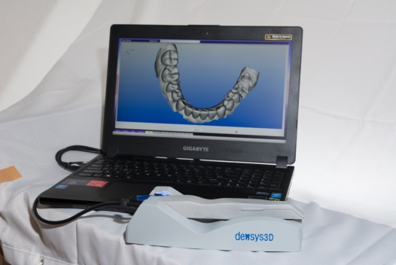 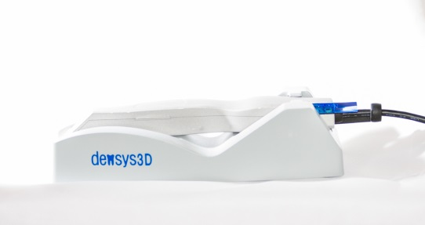 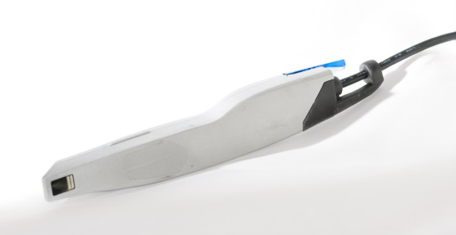

Figure 1 – MIA3d System

The wand captures intra oral video data which is reconstructed into three dimensional files. The wand contains:

* Camera
* Optics
* LED lighting
* Feed cables enclosed in biologically non-reactive casing.

1. **Electrical Medical Grade Power Adaptor** (laptop version)

Power – Win (manufacturer), model PW-M160A-1Y190H

**V.** **Densys SpeedScan Spray**

**VI.** **Densys SpeedScan Separator**

### Wand Hardware Description

Hand piece is impervious to fluid entry. It is made of material that is non-biological tissue reactive. It weighs less than 200 grams and easily fits into the oral cavity whilst leaving room for the hand to grip the wand end extra-orally.

The hardware specifications are as follows:

* Optic system with glass lenses and glass optics.
* Video:
  + Transfer: Color or monochrome real time image acquisition from the wand camera on a continuous basis.
  + Transfer rate: Multi Frames per Second (FPS).
  + Format: Composite Signal from the camera.
  + Focus Range: 0mm – 18 mm.
  + FOV: 16mm x 9mm.
  + Light Source: LED.
  + Pixel viewing size on object of at least 20 microns or greater.
  + Resolution: 1280 X 1024 pixels.
* Connection to the PC / Laptop: USB 3.0
* Input power: 2xUSB 3.0 cable
* Disposable cover of the viewing window.

### Wand Physical Description

The wand’s weight and appearance are as follows:

* Shape – the hand piece is characterized by a lack of sharp edges or rigid surfaces so the patients’ mouth can’t be harmed.
* Weight – 200 grams.
* Handle size – 2.5cm diameter, 200mm long
* Cable length – 2m

### Work Station Description

The minimum hardware specifications are as follows:

**Computer/Laptop**

Processor: Intel Core i7

Memory: 8 GB 240-Pin DIMM

Power Supply: 500W medical grade - computer work station/ 140W medical grade adaptor -laptop

GPU: GTX 970 for desktops / GTX 970M for laptops

Hard disc: 1 TB

SSD: recommended at least 128 GB

OP – Windows 10 64-bit

The laptop needed for use is **MSI GS60 Ghost Pro-002**

**System Connections**

* Wand: 2 x USB 3.0.
* Communication: Wired Ethernet or Wi-Fi connection

|  |  |
| --- | --- |
|  | Note: The Wand includes a stand with a calibration step |

### Safety Standards

|  |  |
| --- | --- |
|  | Note: The wand has a handle that gives the operator a secure grip |

**EMC** – The system complies with the requirements of the IEC 60601-1-2:2007 standard.

**Safety** – The system complies with the requirements of the IEC 60601-1:2005 standard.

### Electrical Hazards

|  |  |
| --- | --- |
|  | **NOTE:** The device is supplied with a medical grade power adaptor and cables as listed below, and maybe only be used when the supplied power adaptor |
|  | **NOTE**: The device may only be used when the supplied power adaptor is inserted directly in to the mains outlet. |
|  | **NOTE:** Do not change the power cable to the mains outlet |
|  | **NOTE:** Do not use an interface or adaptor to insert several electrical appliances in the same outlet with the device |

The device has been tested and found to comply with the limits for medical devices under the IEC 60601-1-2 standard. These limits are designed to provide reasonable protection against harmful interference in a typical clinical installation. This device generates, uses, and can radiate radio frequency energy. If not installed and used in accordance with the instructions, it may cause harmful interference to other devices in the vicinity. However, it should be noted that interference to other devices is not necessarily caused by this instrument but may come from another source. Whether or not this device is interfering with other devices can be easily determined by turning it off and on.

The user is encouraged to try to correct the interference by one or more of the following measures:

* Reorient or relocate the receiving device.
* Increase the separation between the devices.
* Connect the device into an outlet on a circuit different from that which was previously used.
* Consult Densys3D for help.

Interference to the device may be caused by portable and mobile RF communication equipment. In case of an interruption, check that the interruption is not caused by communication equipment operating in the vicinity.

Use of the system with any accessory, transducer or cable other than those specified may result in increased EMISSIONS or decreased IMMUNITY than those specified.

**Electrical Specifications:**

|  |
| --- |
| * Class II equipment * The equipment may only be used with the medical electrical power supply included, which is one of the two models listed here below.   Power – Win (manufacturer), model PW-M160A-1Y190H |
| * Type BF applied part |
| * No protection against ingress of water (IPX0) |
| * Equipment not suitable for use in the presence of flammable mixtures |
| * The unit is classified as continuous operation device |
| * Guidance and manufacturer’s declaration – electromagnetic emissions |

### Operational Environment

|  |  |  |
| --- | --- | --- |
| * The maximum operational altitude is 6561ft (2000 meter) * Operating temperature: 15°C to 40°C * Humidity: 10%- 90% RH   The MIA3d system is intended for use in the electromagnetic environment specified below. The customer or the user of the MIA3d should insure that it is used in an environment that meets these requirements. | | |
| **Emissions test** | **Compliance** | **Electromagnetic environment – guidance** |
| RF emissions  CISPR 11 | Group 1 | The MIA3d system uses RF energy only for its internal operations. Therefore, its RF emissions are very low and unlikely to interfere with nearby electronic equipment. |
| RF emissions  CISPR 11 | Class A | The MIA3d system is suitable for use in all establishments other than domestic. It may be used in domestic establishments and those directly connected to the public low-voltage power supply network that supplies buildings used for domestic purposes, provided the following warning is heeded:  **Warning: This system is intended for use by healthcare professionals only. This system may cause radio interference or may disrupt the operation of nearby equipment. It may be necessary to take mitigation measures, such as re-orienting or relocating the MIA3d system or shielding the location.** |
| Harmonic emissions  IEC 61000-3-2 | Not applicable |
| Voltage fluctuations/  flicker emissions  IEC 61000-3-3 | Not applicable |

### Non-operational Environment

* Maximum Altitude: 6561ft (2000 meter)
* Temperature: Less than - 15° and above 40°C
* Humidity: 90% @55°C non-condensing.
* Vibration: MIL 810-514E Transportation Vibration Test or equivalent.
* Shipping Shock: Per ASTM 4169-98.

### Disinfection and Cleaning

The Mia3d Wand may be cleaned as below or may be used in conjunction with a condom, especially designed and optically suitable for MIA3d use.

**Condom**

Place correctly over the anterior part of the wand and do NOT obstruct the viewing window.

The Mia3D Wand contains optics and electronics, and therefore must not be placed in a bath or under running water for cleaning purposes.

1. **To clean and disinfect the wand:**
   1. The wand should be wiped backwards and forwards with a damp cloth of Esteer Sept wipes (manufactured by Esteer Pharma Gmbh) to remove any visible gross material or fluid on the wand surface.
   2. The wand should be dried with a new disposable tissue from a packet of regular tissues. Or alternatively, a disposable dry cloth wipe.
   3. The wand should be wiped backward and forward with a damp cloth of Ruhof Orthozime® enzymatic detergent diluted according to the manufacturer’s instructions.
   4. The wand should be wiped with cloth duped with distilled water.
   5. The wand should be placed on a clean table top or other horizontal surface and using Propano AF spray (manufactured by Esteer Pharma Gmbh) sprayed evenly from a distance of 30cm on all sides with the exception of the bottom side adjacent to the surface. It should be left to dry for one minute.
   6. The wand should be rotated and the steps listed above should be repeated to clean the side of the wand adjacent to the horizontal surface.

|  |  |
| --- | --- |
|  | Note: Please refer to Esteer Pharma Gmbh web site for cleaning material and wipes information: <http://www.esteer.com/>  Please refer to Ruhof Corporation web site for cleaning detergent information: <http://www.ruhof.com/CatalogProducts.asp?nProductsID=82> |

1. **To clean the viewing window:**
2. Place some optic glass cleaning liquid on the wipe tissue provided.
3. Wipe the viewing window GENTLY in one direction only —**do not** rub back and forth and do not scratch the viewing glass.

|  |  |
| --- | --- |
|  | Caution: If you wipe vigorously you may scratch the viewing glass. |

1. Dry the viewing window GENTLY with a dry wipe, wiping in one direction only.
2. **When not in use, place the wand in its correct position on the wand stand.**

|  |  |
| --- | --- |
|  | **Warning:** The handpiece is not delivered sterile, nor should it be sterile for use.  Implementation of the cleaning protocol before use, and in between patients, is required for correct maintenance of the wand. |

### 

### Biocompatibility

The handpiece is designed using materials which comply with EN ISO 10993-1:2009 standard.

The level of contact as stated in the standard: surface device in limited contact (<24 hours) with a mucosal membrane.

### CAUTION

|  |  |
| --- | --- |
|  | Caution: This section contains vital maintenance information that you must follow to avoid damaging the equipment. |

Densys3D hardware contains highly-refined optics and electronics. To avoid damaging this equipment:

* Do not drop or bang the wand.
* Avoid contact of the wand with any materials or solutions other than those authorized in the user manual.
* Do not immerse the handpiece in solutions or baths.
* Do not place the wand under a running tap.
* Do not place the wand in an autoclave or a dry heat sterilizer.
* Do not wet the wand, or any part of the Densys3D system, other than in a manner or with a material authorized for use in the user manual.

## Installation

|  |  |
| --- | --- |
|  | Caution: Unpacking and installation of the Mia3d system must only be performed by a qualified Densys3D technician. |

### Unpacking and Inspection

Unpack each Mia3d system component and inspect for physical damage such as scratched panels or damaged connectors, etc. If any damage is noted, immediately notify the supplier so that the damaged components can be replaced.

Make sure to save all packaging material in case repackaging and shipment is necessary. Verify that all listed items were received.

If any item is missing, notify the supplier. Each Mia3d system component is shipped packaged in an individual protective container, or packed in a single box.

The laptop is supplied in its own box from the laptop manufacturer, by the distributor.

The following components should be included in the box supplied from densys3D for the laptop system:

|  |  |  |
| --- | --- | --- |
| **Item** | **Supplied** | **Part No.** |
| Camera wand assembly | 1 | D5020 |
| Wand Stand | 1 | D4051 |
| Bottle of SpeedScan Spray | 1 | D4052 |
| Bottle of SpeedScan Separator | 1 | D5053 |

The following components should be included in the box supplied by the distributor for the laptop system

|  |  |  |
| --- | --- | --- |
| **Item** | **Supplied** | **Part No.** |
| Laptop | 1 | D5020 |
| USB Foot-pedal | 1 | D4051 |
| Cooler fan stand for laptop |  | D4057 |
| USB hub | 1 | D4052 |
| Mouse | 1 | D5053 |

## Mia3D Operating Instructions

Mia3d operates on a Windows 10 Operation System.

The following instructions lead you through all the Mia3d wizard pages.

|  |  |
| --- | --- |
|  | Note:The use of the device is restricted to trained personnel only. |
|  |  |
|  | Note: It is recommended for the User to change the password for Windows account at the first use of the system, and to change it frequently, once in 6 month. |

The following instructions lead you through all the Mia3d wizard pages.

|  |  |
| --- | --- |
|  | CAUTION: Place the wand when not in use face down on the stand |

|  |  |
| --- | --- |
|  | Note: The actual implementation of the scan takes less than 60 seconds. |

### Principal Navigation Aids

In addition to the regular progression of the wizard pages initiated by task executions, you can also navigate between the pages as follows:

* To progress to the next page, click on the green colored button.
* To return to the previous page, click on the blue colored  button.
* To go to the exit page, click on the red colored button.

### Wizard Page Tabs

The tabs at the bottom of each page view give you instant indication of how far the wizard has advanced but they are **NOT** used for navigation between wizard pages.

### Pre-Scan setup

|  |  |
| --- | --- |
|  | Caution: Before starting a dental scan it is essential to implement the steps described in Pre-Scan setup. |

|  |  |  |  |  |  |  |  |  |  |  |
| --- | --- | --- | --- | --- | --- | --- | --- | --- | --- | --- |
| Activating the Application | | | | | | | | | | |
|  | To launch the application, click the Densys3D icon on your Desktop, or in the Task Bar. The Densys3D license page is displayed.  1 | | | | | | | | |  | | | |
|  |  | | | | | | | | |  | | | |
| Patient Selection | | | | | | | | | | |
| 1. | The Patient Details page is displayed. Click **New Patient** to add a new patient to the patient directory or **Existing Patient** to perform a scan for one of your existing patients.  2  If you selected **New Patient**, the New Patient Details page is displayed. If you selected **Existing Patient**, skip to the next step in these instructions.  3 | | | | | | |  | | | | |
| 2. | In the **New Patient Details** page, enter the following details in the designated fields:   * **Last Name**  – Mandatory Field * **First Name** – Mandatory Field * **ID no.** – Mandatory Field * **Date of birth** * **Address** * **E-mail** * **Phone no. (Mobile, Home, Work**)   After filling in the patient information, click **Next.**  This will automatically register the patient and proceed to the next wizard page. | | | | | | | | |  | | | |
|  | If you select **Existing Patient** in the **Patient Details** page, a pull down list of existing patients will be displayed. You can select one of the existing patients from this pull down list.  4  You can then view and edit patient details (see the description for the **New Patient** page in the previous step).  After changing patient details click **Next** to proceed to the next wizard page.  To view all previous scans from this patient click the **Scan History** button on the bottom left corner of the screen. | | | | | | | | |  | | | |
|  |  | | | | | | | | |  | | | |
| Restoration | | | | | | | | | | |
| 1. | | In the **Restoration** page, click on a scan option to select it.  5  The scan options are:   * **3 Quarter Crown** 3 quarters * **Scan Completion** * **Coping coping** * **Full crown full-crown** * **Inlay, Onlay inlay-onlay** * **Mandibular Full Mouth mandibular** * **Maxilla Full Mouth maxilla** * **Opposing Occlusion opposing** * **Quadrant Scan quadrant** * **Veneer veneer** * **Buccal** 3 quarters   **Bridge bridge** | | | | |  | | | |
| 2. | | If you select the Bridge option, the **Abutment abutment** or **Pontic** pontic indicators are activated.  Click on each of the numbered teeth you want to include in the scan:   * The selected tooth displays the icon for the treatment chosen. * You can undo your tooth selection by clicking again. | | | | | | | | |
| 3. | | Click **Next** to save the scan setup and to continue to the next step. | | | | | | | | |
| Pre-Scan Setup | | | | | | | | | | |
| 1. | | Setup the wand:   * Ensure that the wand is cleaned and disinfected to prevent cross infection before use as specified in the Disinfection section. * Check that the viewing window is clean and dirt free, especially for fingerprints which are difficult to see and which will prevent scanning. If it is dirty preform the cleaning procedure detailed in the Disinfection section. | | | | | | | | |
| 2. | | For prepped teeth prepare the patient with two retraction cords, and remove one cord before proceeding to the next step. Use the Roeko Comprecap by Coltene or equivalent, adjusted to the prepped tooth to see the margin clearly. Biting on the sponge pushes the soft tissue away from the tooth allowing the margin to be clearly imaged. This is absolutely NECESSARY for prepped teeth.  Make certain there is no bleeding in the area of the intra oral impression.  The scanner will not work if there is local bleeding. | | | | | | | | |
| 3. | | Apply the spray   * Shake the spray can vigorously * Attach nozzle to spray can. * If the nozzle has a white residue from a previous use, clean the residue from the nozzle * Clean, dry and isolate the teeth and any non-movable soft tissue around the teeth from any fluid present in the oral cavity. * Hold spray approximately 8mm from teeth. * Apply spray evenly to the teeth and the adjacent gingivae by moving nozzle over the areas that are to be scanned.   Don’t forget to spray any non-movable soft tissue in the scan area.   * DO NOT spray movable soft tissue. This will cause an inaccurate scan. * If you have sprayed the moveable soft tissue wipe the spray off the tissue before it dries | | | | | | | | |
|  | | * Wait for spray to dry while holding the movable soft tissue, away from the other tissues. | | | | | | | | |
|  | | | | | Note: **Keeping the sprayed tooth dry is essential to achieving a quality scan. Any wetting of the powder will result reduce scan accuracy**. | | | | | | |
|  | | | | |  | | | | | | |
| Scan Screen | | | | | | | | | | |
|  | | After completing the pre-scan setup, click **Next** from the Restoration page (step 3) to open the Scan screen. | | | | | | | | |
|  | | | | Note: Try and parallel the camera to the tooth during the scanning procedure.  Do not touch the tooth with the camera during the scanning procedure. | | | | | | |
|  | | The Scan screen consists of two windows.   * The left (PREVIEW) window shows the tooth before computation of the data to 3D. * The right (SCAN) window presents the scan progress in real-time, and the 3D results after the initial data computation to 3D.   As the scan proceeds the currently processed data is displayed in the scan window in green.  SD Scan | | | | |  | | | |
|  | | | | Note: The scanning method described in the following steps is a suggested, recommended method. Some users may prefer to follow a different method. A new user is advised to practice his scanning technique in the preview window before activating the scan. | | | | | | |
| Help Tag | | | | | | | | | | |
|  | | There is a Help tag at the bottom-right of the screen.  If pressed a film which shows the appropriate recommended scanning method appears. | | | | | | | | |
| Preview | | | | | | | | | | |
|  | | | **To activate the PREVIEW do one of the following steps:**   1. Click the start button  under the left window (labeled PREVIEW). 2. Press the space bar on your keyboard 3. Press once on the Foot Pedal   **To change the preferred PREVIEW aspect do one of the following steps:**   1. Click the Rotate button rotate to turn the view 90 degrees 2. Click the Mirror button MIRROR to mirror the view 3. Click the flip button FLIP to flip the view   **To stop the PREVIEW do one of the following steps:**   1. Click the stop button  under the left window (labeled PREVIEW). 2. Press once more the space bar on your keyboard 3. Press once more on the Foot Pedal   SD Preview | | | | | | | |
|  | | | | | |  | | | | |
| Scanning | | | | | | | | | | |
|  | | | |  | | | | | | |
|  | | | | Caution: It is preferable that neither direct sunlight, nor the unit halogen light should be directed intra orally during scanning. | | | | | | |
|  | | | | Review the following scanning guidelines to obtain high quality scans.   * Always check pre scan that the wand lens is clean, especially looking for fingerprints on the wand. If there are finger prints or other dirt clean the wand window. * Always spray and scan the gingivae around the teeth to be scanned, * Preferably the scan should start by previewing and scanning surfaces, eg buccal and occlusal. * Always try and hold the wand as parallel as possible to the surface scanned. Inter-proximally turn the wand to position it as parallel as possible to the surface scanned. Please note, this is difficult to achieve and you will have to compromise on the ideal positioning. * Hold the wand as close as possible to the surface to be scanned, preferably not touching the surface. * For tricky surfaces such as inter- proximal surfaces, hold the wand in position for a second or so. * All scans should be a continuous smooth movement and not jerked with sudden movements. * When moving the wand from any surface to the occlusal surface, slow down and roll with minimum translation of the wand. * When scanning around corners or sharp angles move the wand slightly slower. * Keep the area you want to scan in the center of the preview screen. * If you lose the teeth from the scan picture the scan will not have data to continue the scan, and will show red screen scan data. * If you jerk suddenly away from the area scanned move back to it as quick as possible * If you begin to lose the scan because of position or jerked movement the latest scan screen data will change from green to yellow – this is a warning to try and improve the scan technique * If you do lose the scan the latest scan screen data on the screen will be pink/red. The scan will stop unless you return to the same position or press the pedal once to pause * For better results, hold the wand as close as possible to the teeth. * Do not touch the teeth with the wand. It is preferable to move the wand only in one sweep in one direction and NOT in a back and forth “polishing” movement.   METHOD  There are different methods of scanning, which should follow the scan principles above.  It is however best if the scan should be done according to the following method.   * To use automatic bite start on the same side amd same surface between scans of teeth in opposing occlusions. Ie upper left buccal and lower left buccal. * Create a skeleton of the jaw in one movement without pausing by scanning from one side of the jaw the posterior occlusal sources followed by lingual / palatal anterior surfaces, and then followed by the posterior occlusal surfaces on the other side of the jaw. * When creating the skeleton try and scan some very small part of the buccal / lingual / palatal surfaces, This can be done by a very slow gentle rocking of the scanner when positioned occlusally * In the anterior teeth it is very important if possible to also get even a small amount of labial tooth surfaces by extremely gentle rocking of the scanner. * Before scanning between 3 & 3 pause and resume. This will increase the scan accuracy. * When scanning prepped teeth angle the wand slowly and gently at angle towards the vertical to see and scan the mesial and distal areas. Distal areas are easier to see then mesial areas. The prepped teeth can also be scanned from the lingual or labial by slow gentle movement to angle the scanner at a more parallel position opposite the distal / mesial surfaces. * Check to see if all critical areas are scanned before accepting the scan, None critical areas can use hole fill, which has a lesser accuracy. * Use PAUSE RESUME to fill in missing areas * If the scan has been converted by pressing accept to an .stl file format you can still add scan areas in by doing COMPLETE, from the Scan History | | | | | | |
| 1. | | | | Once you are satisfied that the tooth is in focus and the wand is positioned with the chosen view, you can start the scan using the same method used to activate the preview:   1. Click the arrow button  under the window to the right (labeled SCAN) to start the scan. 2. Press the space bar on your keyboard. 3. Press once on the Foot Pedal. | | | | | | |
|  | | | | Note: Each operator will develop their own favored scanning method and there is no obligation to follow the surfaces in the sequences listed in the above example, but the principles of scanning have to be followed. | | | | | | |
| 2. | As you move the wand a real time scan appears in the SCAN window. It covers the same area that  is shown in the PREVIEW window to the left.  The colored dots appearing on the scan screen show the latest data coming into the scan in real-time.  Green dots ­– good data coming into the scan is colored green on the right scan window.  Yellow dots – when the data coming in is yellow the operator should relate to one of the following potential problems about to happen   1. The scanner is being held to far away and is out of focus 2. The scanner is being held at too great an angle to the tooth 3. The operator has jerked during the scanning and missed an area – he has to go back to the area last scanned successfully   Pink dots – the situation is critical and unless the operator corrects as above he will wither get a  sub-standard scan or the screen will progress to a red color and stop  Red dots – the screen and scanning has stopped and the operator must go back and redo or pause and resume  PAUSE : RESUME  There are a number of reasons the scan user may want to pause resume.   1. After getting red dots and a scan freeze. 2. To increase accuracy by pausing between canines 3. To do a 180 degree turn in the anterior section of the jaw.     Method:   1. Press once for pause 2. Place scanner over a prescanned area with unique anatomy, preferably occlusal surfaces of posterior teeth. 3. Move the scanner over two to three teeth and hold still 4. When a beep is heard and the green dots appear re start the scan 5. If you are unsuccessful you will be offered the chance to redo the resume.   SCAN ERROR REMOVAL  In case of a scan error which would prevent a clear good scan, the scanner will stop and ask you to automatically delete the bad area by pressing once and resume the scan with operation of the PAUSE RESUME mode. Please consider changing the scanner method of operational use when rescanning. | | | | | | | | | |
| Audio | | | | | | | | | | |
|  | There are audio sounds accompanying the scan that demonstrate the different colored screens.  These vary from system to system. | | | | | | | | | |
| Implants – Scan Bodies | | | | | | | | | | |
|  |  | | | | | | | | | |
|  | NOTE: Do not use scan bodies or scan implant parts that are symmetrical in shape or have large curved surfaces    **NOTE:** Use scan bodies that have multiple angular faces in white peek material | | | | | | | | | |
|  | Scan bodies that are appropriate include:   1. Densys Scan Body 2. Straumann Scan Body – 3. Sirona Scan Body   Densys cannot guarantee a successful scan with other implant parts or scan bodies. | | | | | | | | | |
| 3. | When you are satisfied that you have scanned all the areas of the tooth required for a successful restoration, stop the scan by using the same methods as for starting the preview/scan:   1. Click the Stop  button under the SCAN window with the mouse 2. Press once again on the space bar on your keyboard 3. Press once again on the Foot Pedal   The scan can be viewed by using the mouse, for zoom, pan and rotation.  During the processing time of the scan a green progress bar at the bottom of the screen indicates the scan completion percentage.  When processing is finished (the bar has completed its progress) a message pops up asking you to accept or reject the scan and the **Accept** and **Reject** buttons are enabled.  scanned acept | | | | | | | | | |
| 4. | Click **Accept** to accept the scan or **Reject** to redo the scan. | | | | | | | | | |
| Scan Dialog Screen | | | | | | | | |
|  | After accepting the scan, the application presents you with a number of options. To activate an option, mark the circle next to it and click in the checkbox under the options list:  New Treatment — saves the current scan and returns to the restoration screen for initiating a new dental scan for this same patient.  Reset current scan— deletes the current scan data, and returns you to the start of the process in the restoration screen.  Finalize last scan – Reprocesses the scan data to generate a higher resolution 3D image of the scan. This phase can be delayed until later when patient is not present.  Mark edge – Opens the Edge Marking utility kit (refer to Mark Edge section)  Scan History – Moves to the Scan History page.  OD1 | | | | | |  | |

|  |
| --- |
| Finalize Last Scan |

|  |
| --- |
| Note: The operator must wait for the scan finalizing to finish to continue scanning |

Recalculation gives a higher resolution scan that many operators prefer to work with. When the scan finalizing is in process a task bar shows underneath the screen to the process of the calculation. During this time the scanner will not be available for further scanning. Therefore experienced operators may prefer to recalculate after completion of all the clinical scans

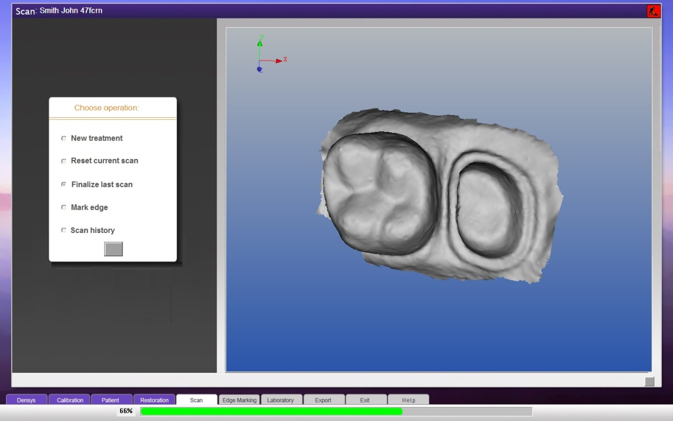

|  |  |  |  |  |
| --- | --- | --- | --- | --- |
| Edge Marking | | | | |
|  | |  | | |
|  | | Note: **Edge marking is essential in restorative virtual impressions to enable an accurate and clearly defined margin for prosthetic manufacture.**  **Edge marking is required for all scans of prepared teeth for prosthetic restoration** | | |
|  | | Edge Marking can be activated from two different wizard screens:  1. Selecting “Mark edge” in the Scan Dialoguescreen will open the Edge Marking utility kit.  2. Selecting “Mark edge” in the Scan History Screen.  OD ME1  Once the Edge Marking operation is selected, an **Edge Marking** menu appears in the upper-right hand of the screen: | | |
|  | | * To zoom, turn the central mouse wheel. * You can move between different views of the chosen image to help you more accurately place the pitons that define the edge. | | |
|  | | * To rotate the 3D view, click and drag the left mouse button. | | |
|  | | * To move the view, click the right mouse button and drag the view. * To zoom in or out, use the central mouse wheel. | | |
| Defining the Edge | | | | |
|  | edge marking tool**To define the edge:**   1. Click the **Freehand** button. 2. To place the first piton, point the mouse at a location as near the edge as possible and click once. You can then circumvent the tooth and a line is automatically placed. 3. Place another piton with a single mouse click. 4. Continue placing pitons around the tooth until you return to the first piton. 5. To complete the edge marking, right click on the first placed piton**.** 6. After completing the line all the placed pitons will be visible**.** | |  |
|  |  | | | |
|  | You can adjust the contour line in several ways:   * Dragging pitons * Small step adjustments * Replacing all the pitons | | | |
|  | **Adjusting the contour line shape by dragging pitons:**   1. Point the mouse cursor at a piton. 2. Click once — hold the mouse down and drag the piton to the desired position. 3. Release the mouse button to deposit the piton.   If there is a contour line it will be updated according to the piton's new location. | | | |
|  | **Adjusting the contour line in small steps**:   1. Add an additional piton by clicking a spot on the contour line. 2. Use this piton by clicking it once and move/drag the contour line. | | | |
|  | **Correcting the contour line by replacing the pitons:**   1. Click the **Correct** button. All the pitons on the contour line will disappear. 2. Place a minimum of three pitons with two of them positioned on the existing contour line. 3. Make a right-mouse click and the new line and contour will replace the old line between the pitons you added.   **Deleting Pitons**   * To delete a single piton point, place the mouse cursor on it and press Delete on the Keyboard. * To delete all pitons**,** Click the **Cancel** button in the menu in the upper right corner of the screen (see the above illustration). – Note: This will also remove the contour line between the pitons. | | | |
|  | **Automatically adjusting the edge marking**  After completing the contour line, there is an option to use the click Auto Edge button. This is a very fine small automatic adjustment of the edge line.  The automatic edge function only works if the edge line is placed within a small distance of the correct clinical edge.  OD ME2 | | | |
|  | **Accepting the edge marking**  When you are satisfied that the edge marking is complete click **Accept** to show the isolated preparation and to save the edge marking.  OD ME3 | | | |
|  | To create a second edge marking line of another preparation, start the process again by clicking the **freehand** button (see the illustration on page 30). | | | |
|  | **Note**: This will only work if you have accepted and saved the previous edge marking. If you click the **Freehand** before accepting the edge marking, the placed pitons with the contour line will disappear. | | | |
|  | To exit the interactive function click **OK** in the corner of the Edge Marking screen.  Select one of the following options:   * To exit the edge marking process click. * To export the files resulted from the edge marking process, click Export**.** | | | |

|  |
| --- |
| Scan History |

The Scan History page can be opened from the Exit screen (refer to Exit Screen) or from the Existing Patient screen (Refer to Existing Patient Screen).

The Scan History screen displays all the saved scans of the patient and enables various actions regarding the scans.

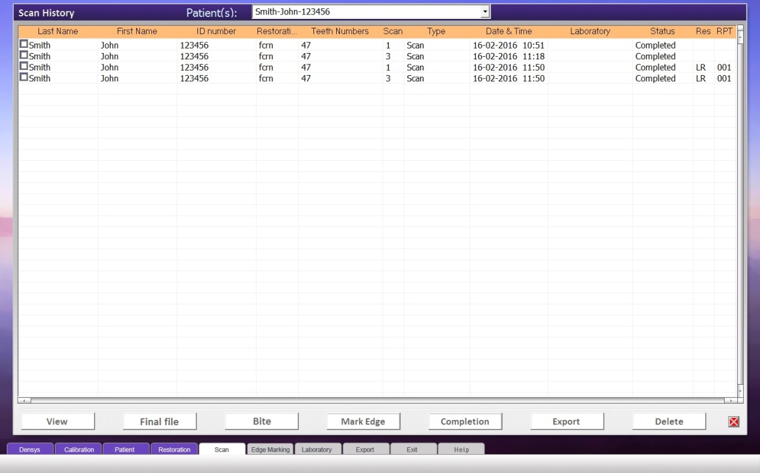

The columns in the Scan History screen from left to right are:

* A box for option selection – to select one or more of the scans to view
* Last Name – of the Patient the scan pertains to
* First Name - of the Patient the scan pertains to
* ID no. - of the Patient the scan pertains to
* Restoration – Restoration Type of the scan

Qcrn - 3 Quarter Crown

Addn - Scan Completion

Cpng - Coping

Fcrn - Full crown

Inly - Inlay, Onlay

Mndb - Mandibular Full Mouth

Mxlr - Maxilla Full Mouth

Occl - Opposing Occlusion

Qdrt - Quadrant Scan

Vner - Veneer

Bccl - Buccal

Pntc - Bridge

* Teeth numbers – Which teeth were selected for the scan
* Scan – Number of scans performed on the same set of defined teeth
* Type – Scan Type
* Date and Time – Date and time the scan was taken.
* Laboratory – What Laboratory the scan has been exported to
* Status – displays the scan status (Completed / Not Completed)
* Res – Displays HR if the scan is in high resolution
* RPT – Number of times this scan has been finalized

Click on one of the action buttons in the lower portion of the screen to activate a function according to the different sections in this User Manual.

The different buttons are:

**View** – Can view up to 8 different scans (refer to View)

**Final File** – Reprocesses the scan data to generate a higher resolution 3D image of the scan. This phase can be delayed until later when patient is not present.

**Bite** – Prompt you to the Bite Screen. (Refer to Bite)

**Mark Edge** – Opens the scan with the edge marking utility. Can only open one scan for edge marking. (Refer to Edge Marking)

**Completion** – Opens the Scan Completion screen. Only choose 2 scans. (refer to Scan Completion)

**Export** – Prompts you to the Laboratory Screen to choose a laboratory to export the selected scans to. (Refer to Export)

**Delete** – Deletes any selected scans

|  |  |  |  |  |
| --- | --- | --- | --- | --- |
|  | | |  | | --- | | View |   The View Screen can display up to 8 scans.  Each of the views can be independently manipulated with the mouse.  To zoom – Rotate the mouse wheel.  To Pan – Right click and drag.  To Rotate – Left click and drag.  View4scans  The different edge marking outputs can be displayed in the View screen  1. Select the different output files of the edge marking.  2. Click on the View button on the bottom of the screen. | |
|  | | View EdgeM | |
|  | |  | |
| Bite | |

Prior to activating the Bite from the Scan History screen, you must have three scans.

For automatic bite all three scans must start in the same place, eg left buccal, or right buccal.,

* **Restoration Scan**
* **Opposing Occlusion** – this scan should include the occlusal and buccal surfaces of the opposing teeth to the restoration
* **Buccal Scan** – this scan should include the buccal surfaces of both teeth in the occluded position

The scans should start from the same area in the mouth, e.g. distal or mesial. This will bring them into the same alignment in the Bite screen.

**To activate the Bite:**

1. Mark the box in the left-hand column of each of the above scans
2. Click the BITE button (at the bottom of the Scan History screen).

The application displays the Buccal scan and one other scan.

**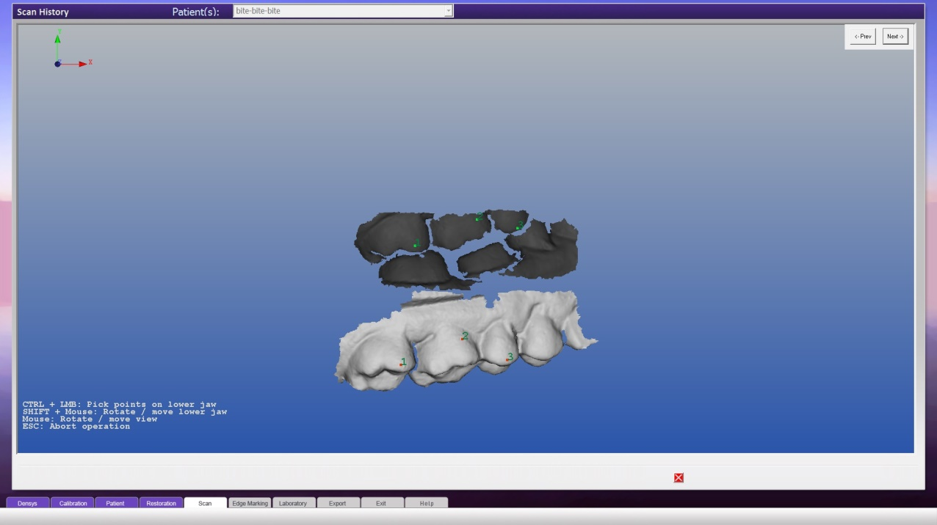**

The lighter colored scan is the active scan.

At any time you can press **Escape** to abort the operation and **I** to toggle the instructions at the bottom left corner of the screen.

1. Manipulating the Scan Views:

To Rotate the scans – drag the left mouse button.

To Move the scans – drag the right mouse button.

To rotate or move only the active scan - Shift + left/right mouse button.

1. Press Control + the left mouse button to mark the scan in at least three points, preferably on different teeth and at different height. The points marked will appear as sequential numbers.

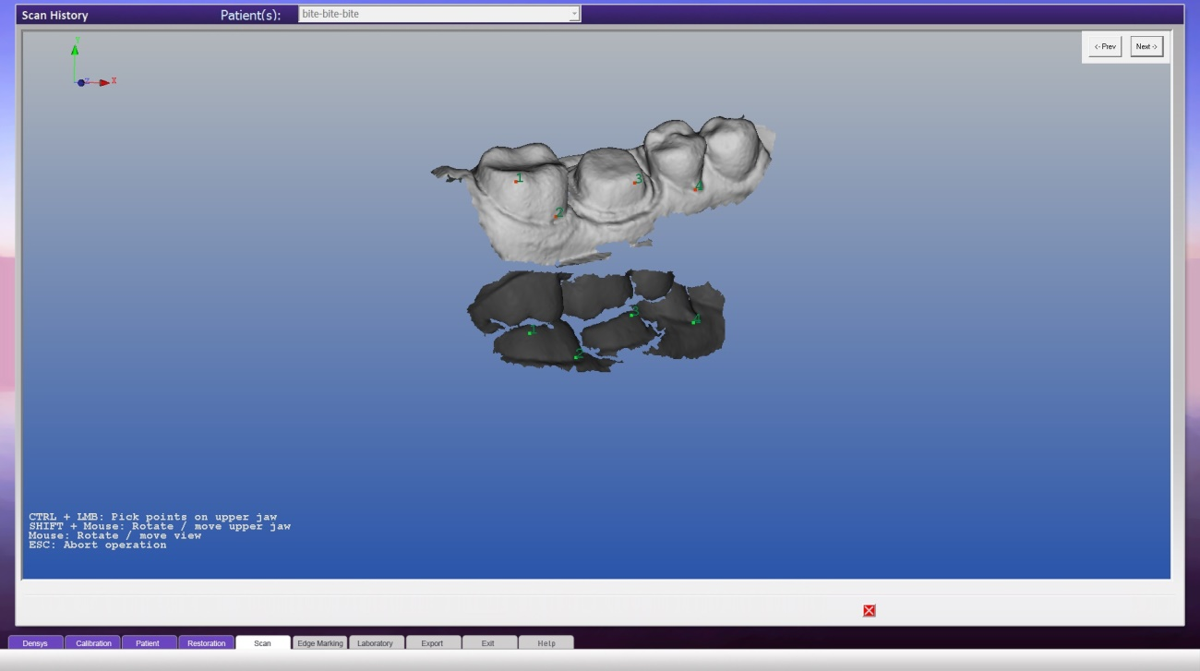

1. To remove a marked point, click the **Previous** button (upper right-hand corner of the screen).
2. When finished click the **Next** button - The active scans will change to the passive scan and vice versa.
3. Position the scan for convenient viewing.
4. Mark the scan in the same tooth and in approximately the position as in the previous scan with the numbers matching.
5. When finished, click **Next** and the third scan will appear on the screen.
6. Repeat the sequence of actions of the first two scans.
7. Click **Next** to finish the alignment.

The Bite will be shown in Automatic Best Fit from three different perspectives:

* On the right hand side of the screen is the Bite
* On the upper-left hand side is the Bite and opposing occlusion.
* On the bottom left is the Bite and buccal.

Any interferences or high areas in the collusion appear in highlighted colors.

As the best fit automatic Bite is an ideal situation and may need manual intervention, you are able to manipulate the Bite in the right hand side of the screen.

1. Manipulate the Bite - press SHIFT + left/right mouse button to manipulate the upper jaw.

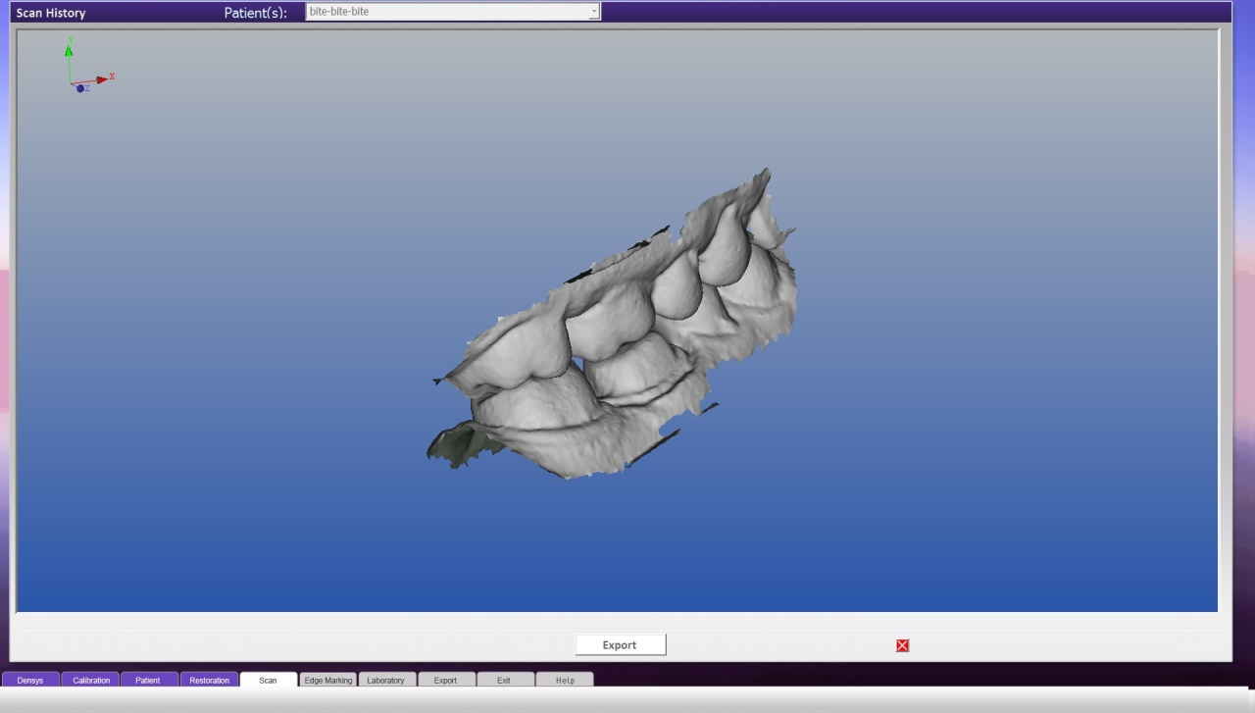

1. Finish:

To export the files (original scan opposing occlusion, buccal and Bite), click the **Export** button (at the top right of the Bite screen).

Click  to exit the Bite and return to the Scan History

The Bite will appear in the TYPE column as “Bite”.

1. To view the Bite, mark the box in the left hand column of the Bite row (in Scan History) and click the **VIEW** button.

AUTOMATIC BITE

For automatic bite all three scans must start in the same place, eg left buccal, or right buccal.,

To activate AUTOMATIC BITE, press the button at the bottom of the SCAN HISTORY screen.

|  |
| --- |
| Scan Completion / Inserting Missing Areas |

Scan completion can be used to add in missing areas or to join adjacent areas, e.g. sextants or quadrants.

Scan completion is semi – automatic.

It will soon be released in a fully automatic version.

|  |  |
| --- | --- |
|  | Note: For all cases there should be an overlap of at least one tooth on the areas to be matched. |

Scan Completion can be activated from the **Scan Dialog** screen or the **Scan History** screen.

**Scan Dialog screen**

1. After the first scan, mark the **Scan Completion** checkbox and click on the **√** box.
2. The application automatically advances to the Restoration screen and selects by default the treatment **Scan Completion**.
3. Click **Next** to go to the Scan screen.
4. Proceed to Preview and Scan (see page 20).
5. Perform the scan.
6. Accept the scan.
7. You will now be prompted the Scan Completion screen

|  |  |
| --- | --- |
|  | REMEMBER start the scan in the same position and orientation as the original scan |

**Scan Completion from the Scan History screen**

1. In the Scan History screen, mark two scans in the left hand column.
2. Click the **COMPLETE** button (at the bottom of the screen)

You will now be prompted to the Scan Completion screen

**Marking the overlapping areas**

1. Mark points according to the procedure described in the BITE section (see page 36).
2. Mark the scan in the same tooth and in approximately the position as in the previous scan with the numbers matching.

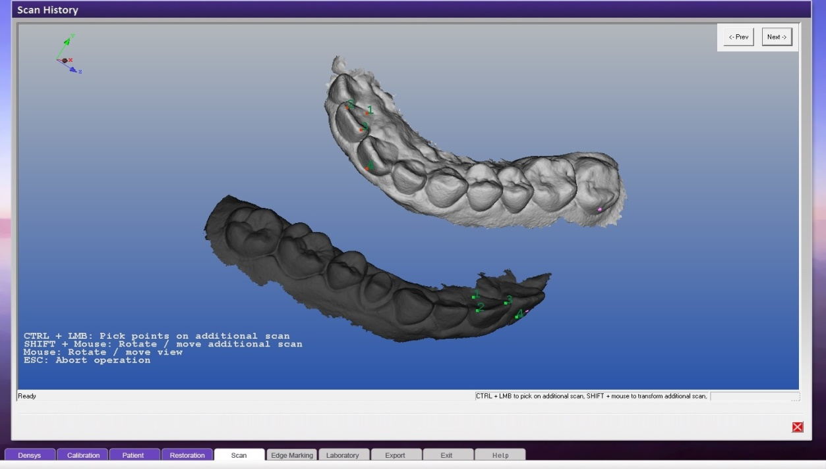

1. Click on Next.

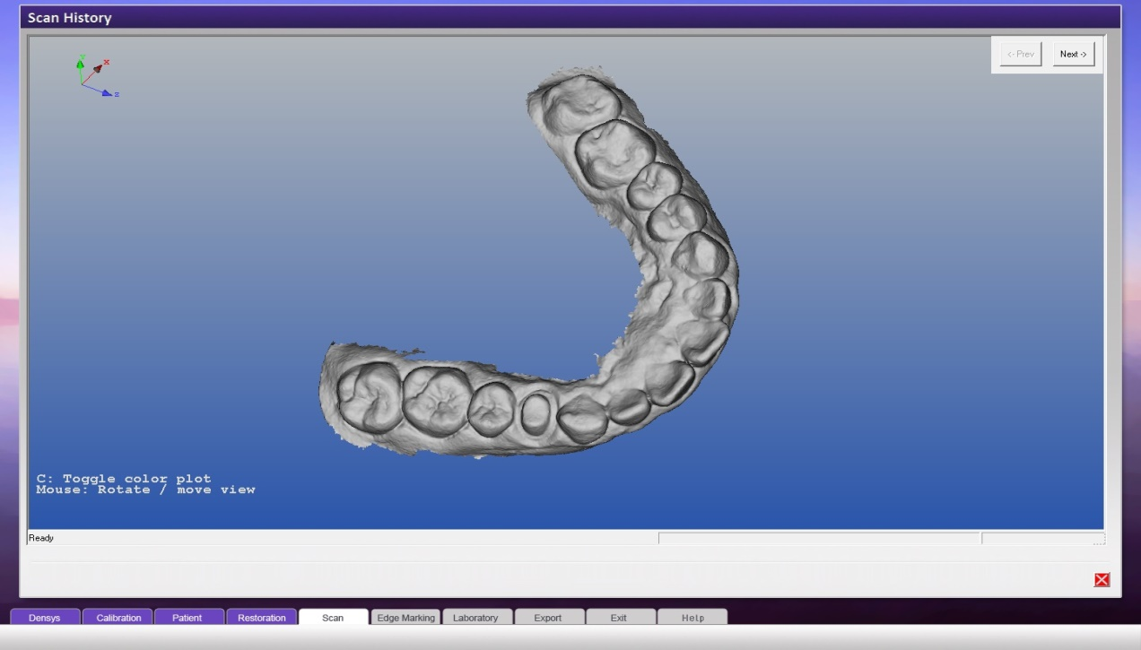

1. Click on Export to export the scan to a laboratory or click on the  to return to the Scan History screen.

|  |
| --- |
| Exporting Scans |

After scanning you can export the scan to a laboratory or other party of your choice.

Export is an option in the screens of Scan History, View, Completion and Bite.

1. Mark **Export Scan** ,the wizard advances to the Check Export Method screen
2. Define the Method of your choice by marking the box in the top corner √ . The left box is for email, and the right box is for FTP – file transfer protocol..

|  |  |
| --- | --- |
|  | Note: Laboratories and FTP are defined in the setup application |

Click on the desired option.

For email

**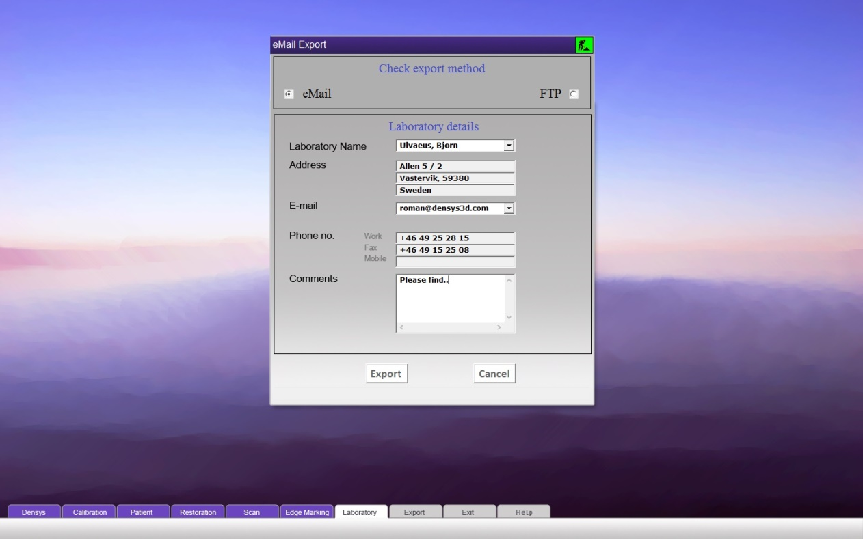**

Authorize the mail

1. Use the mail like a regular mail program and send the mail.

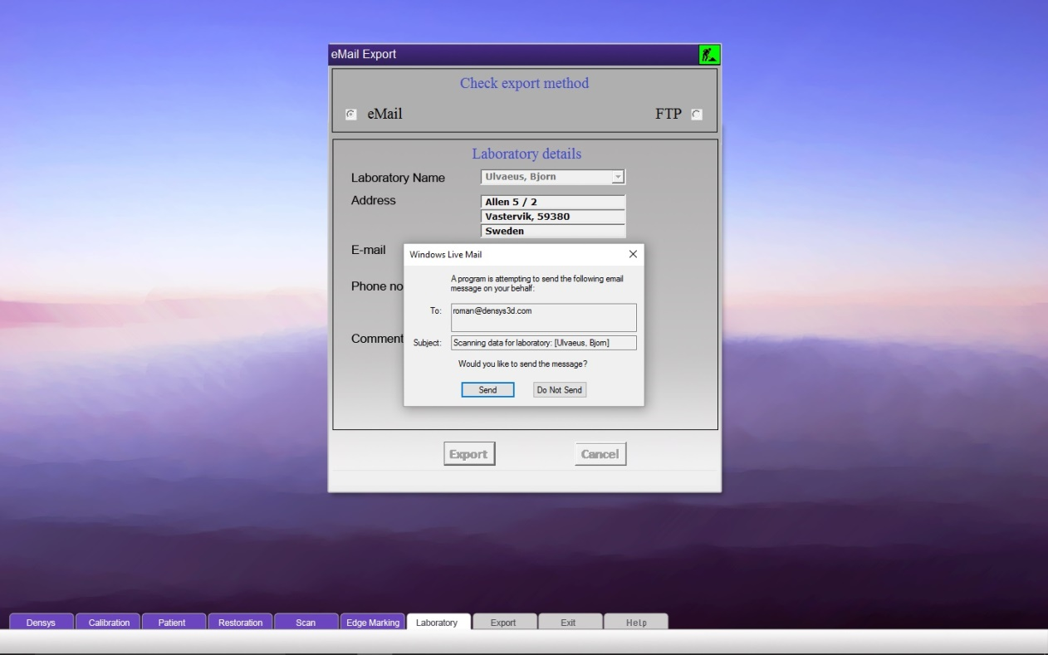

For FTP 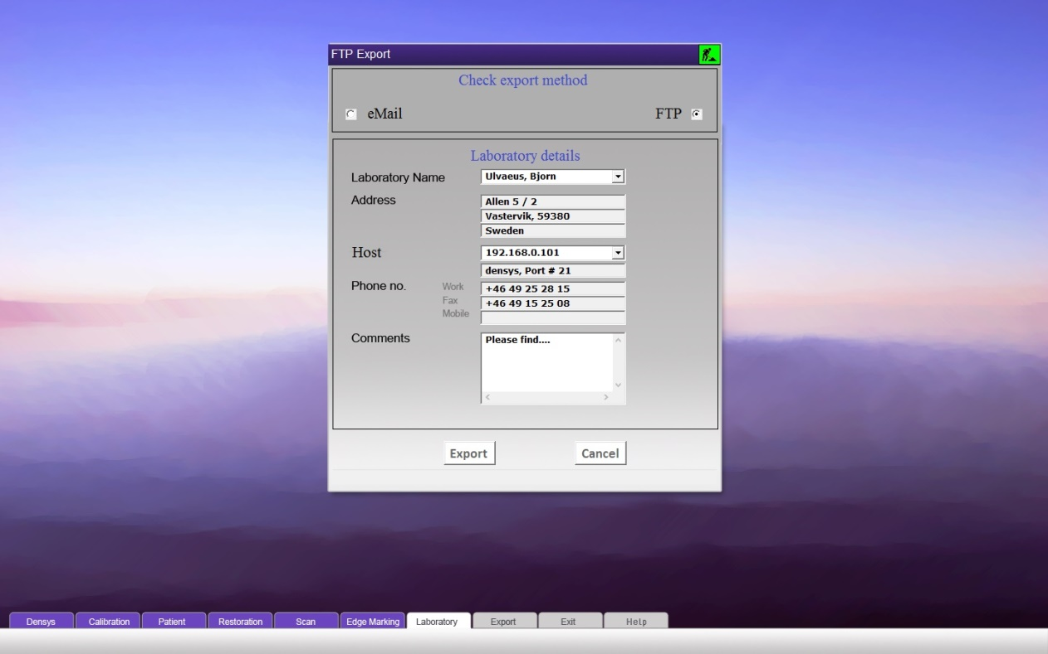

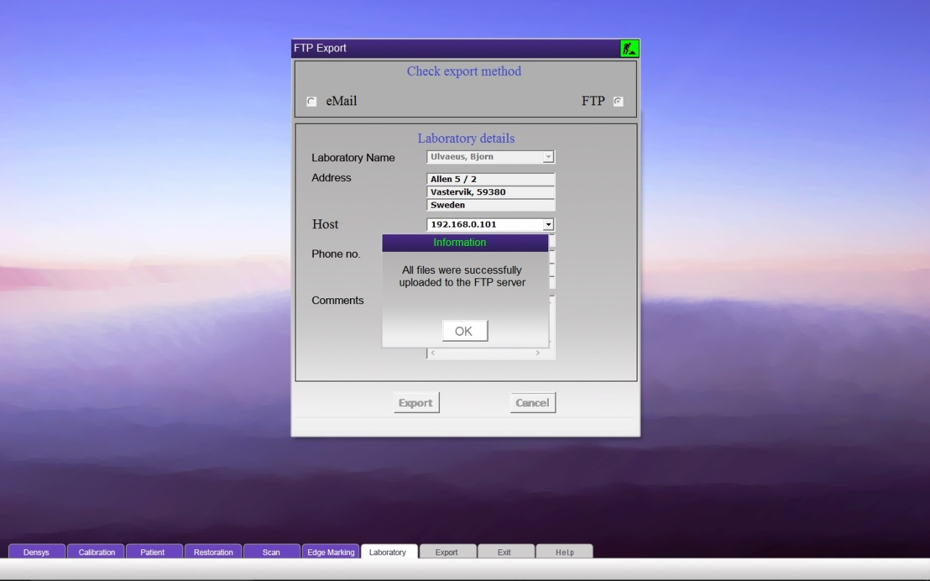

|  |
| --- |
| Exit Screen |

The Exit screen can be opened from the other screens by a click on the  in the bottom right corner.

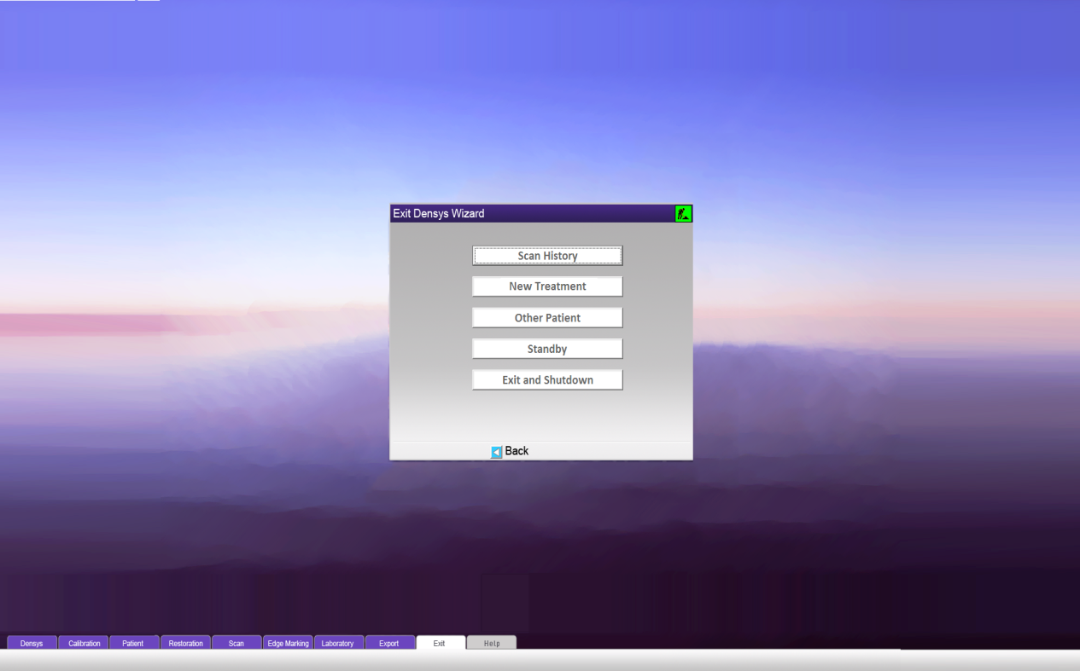

Available options are:

* Scan History – Opens the Scan History screen.
* New Treatment – Opens the Restoration screen to choose a new treatment for the patient.
* Other Patient – Opens the Patient Details screen to choose between a new or existing patient.
* Standby – Goes into standby and displays a screensaver
* Exit and Shutdown – Shuts down the Mia3d program.

### Contact Information

For additional information and any inquires please contact:

densys3D Ltd.  
P.O. Box 804  
Migdal Ha'Emek 2307049 Israel  
Tel: +972-4-644-3606  
Fax: +972-4-654-0535

[Info@densys3d.com](mailto:Info@densys3d.com)